How to package your fuel cell when returning to Fuel Cell Systems Ltd.

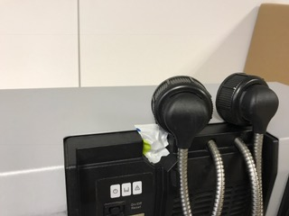

- Tape over the exhaust (as in photo above)
- Clip the fuel connector/s in place
- Place upright in a cardboard box
- Fill the gaps with bubble wrap (or other void fill)
- Tape the box up securely
- Put “THIS WAY UP” stickers on or write it on the sides
- Send to the address below

